**Experienced Company legal Advisor** | Legal Professional | Advocate for Justice



**Marelign**

**Teshome**

company legal advisor

marelignteshome@gmail.com

→

+251937413891



Addis Abeba ,Ethiopia



https://marelignportfolio.vercel.app/



I am an experienced Judge with a strong background in legal interpretation, judicial decision-making, and dispute resolution. Over the course of my career, I have presided over diverse cases, ensuring fairness, impartiality, and adherence to the rule of law.

# Work experience

1. **Federal Justice and Legal Research and Training Institute, Bahir Dar**  
*Assistant Judge & Public Prosecutor*

October 15, 2019 – July 30, 2020

• Assisted senior judges in drafting legal opinions and judgments.

• Represented the public in criminal cases, ensuring fair trial standards.

**2.ANRS Supreme Court, Meket Woreda Court, Filakit**  
*Judge*

August 1, 2020 – July 30, 2022

• Presided over civil, criminal, and family law cases.

• Delivered well-reasoned judgments ensuring justice and impartiality.

**3.ANRS Supreme Court, North Mecha Woreda Court, Mehal Genet  
*Judge***August 1, 2023 – January 8, 2024

* Oversaw high-volume caseloads while ensuring timely justice delivery.
* Applied legal principles and precedents in complex cases.

**4.Abay Insurance S.C., Addis Ababa *Attorney II***February 7, 2024 – September 15, 2024

* Provided legal advice on contracts, insurance claims, and compliance issues.
* Drafted and reviewed legal documents to mitigate risks.
* Represented the company in litigation and dispute resolution matters**.**

# Education

**1.Arbaminch University, Arbaminch  
*Bachelor of Laws (LL.B.)*  
2015 – 2019**

* GPA: 3.36

**2.Debre Markos University, Debre Markos  
*Master of Laws (LL.M.) in Business and Investment Law***

* Candidate; currently at the final stage of thesis defense.

**3. Federal Justice and Legal Research and Training Institute, Bahir Dar***Certificate in Judicial and Prosecutorial Training*  
October 15, 2019 – July 30, 2020

# Work experience

**5.Dashen Bank S.C., Addis Ababa**  
*Attorney*  
**August 22, 2024 – Present**

* Advising the bank on regulatory compliance and contractual matters.
* Drafting and reviewing agreements, policies, and legal correspondences.
* Representing the bank in court and handling legal disputes effectively.

**Volunteer Coordinator – Arbaminch University, Arbaminch, Ethiopia**  
**Since 2019**  
I have actively contributed as a volunteer at Arbaminch University, where I have honed my skills in event coordination and community engagement. I have successfully guided students in developing key skills, coordinated educational and extracurricular activities, and facilitated workshops, demonstrating my ability to lead and motivate teams. Through this role, I have shown a strong commitment to fostering growth, learning, and professional development within the university community.2

I have honed my skills in event coordination and community engagement. I have successfully taught students the necessary skills to prepare for programming contests and efficiently coordinated programming contests, showcasing my ability to lead and motivate teams. I have demonstrated my commitment to fostering growth and development in the field of computer programming.

# Social networks

|  |  |
| --- | --- |
| https://t.me/Marelignt4  marelign Teshome in face book  **Skills** |  |
| **1.Legal Expertise –** Proficient in civil, criminal, commercial, and investment law with strong knowledge of statutes, precedents, and judicial  **2.Contract Drafting & Negotiation** – Skilled in preparing, reviewing, and negotiating contracts and agreements.  **3**. **Legal Research & Analysis** – Strong ability to conduct in-depth research and apply findings to case preparation and decision-making.  **4**. Judicial Decision-Making  **Languages** | 5. **Communication & Advocacy**  6. **Attention to Detail** – Careful and precise in reviewing legal documents, evidence, and procedural compliance.  7. **Time & Case Management** – Capable of managing multiple cases and tasks efficiently under pressure.  8. **Ethics & Integrity** – Dedicated to upholding the highest standards of professional ethics and judicial integrity.  9. • **Computer Literacy** – Proficient in Microsoft Office Suite (Word, Excel, PowerPoint) and legal documentation tools.  • |

**1.Amharic(**native)

**2.English** Professional

* **There are certificates** 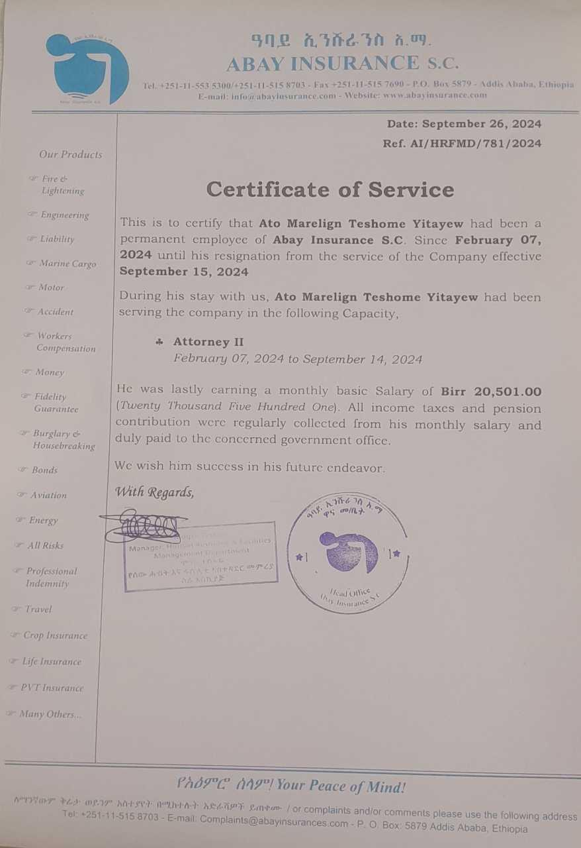
  1. 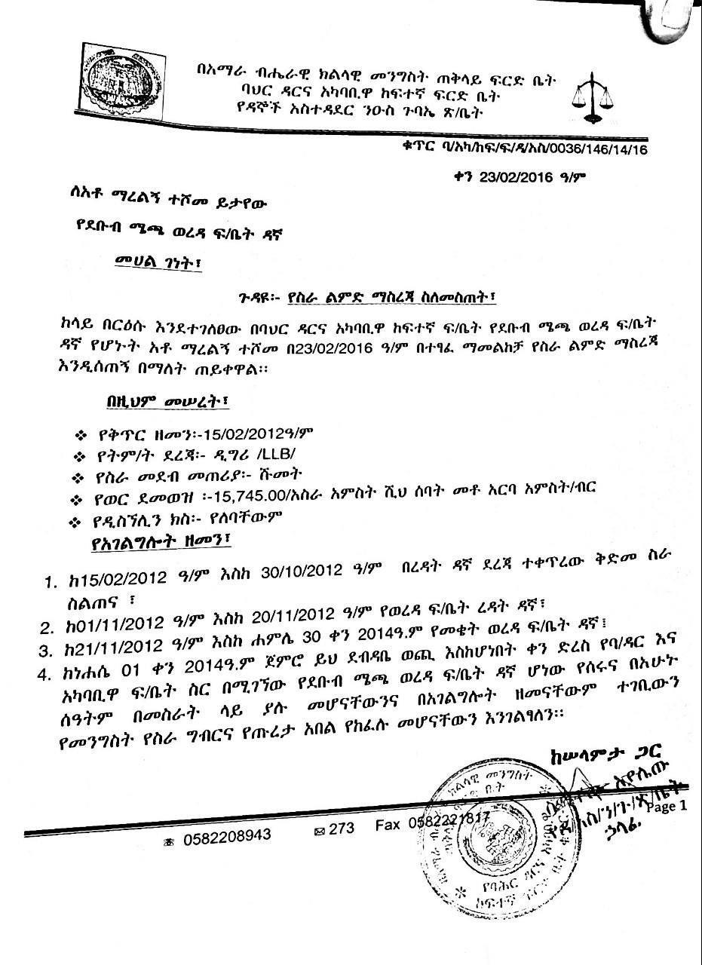
  2. 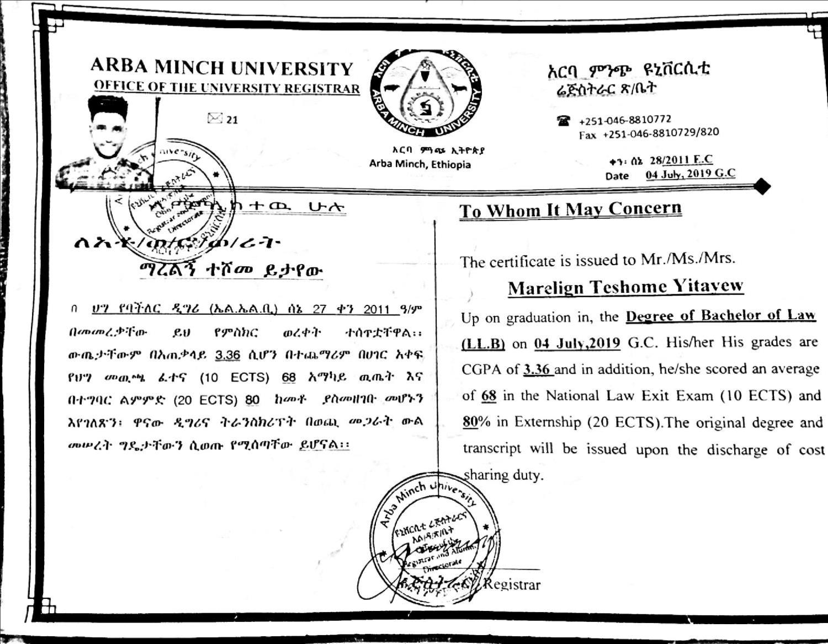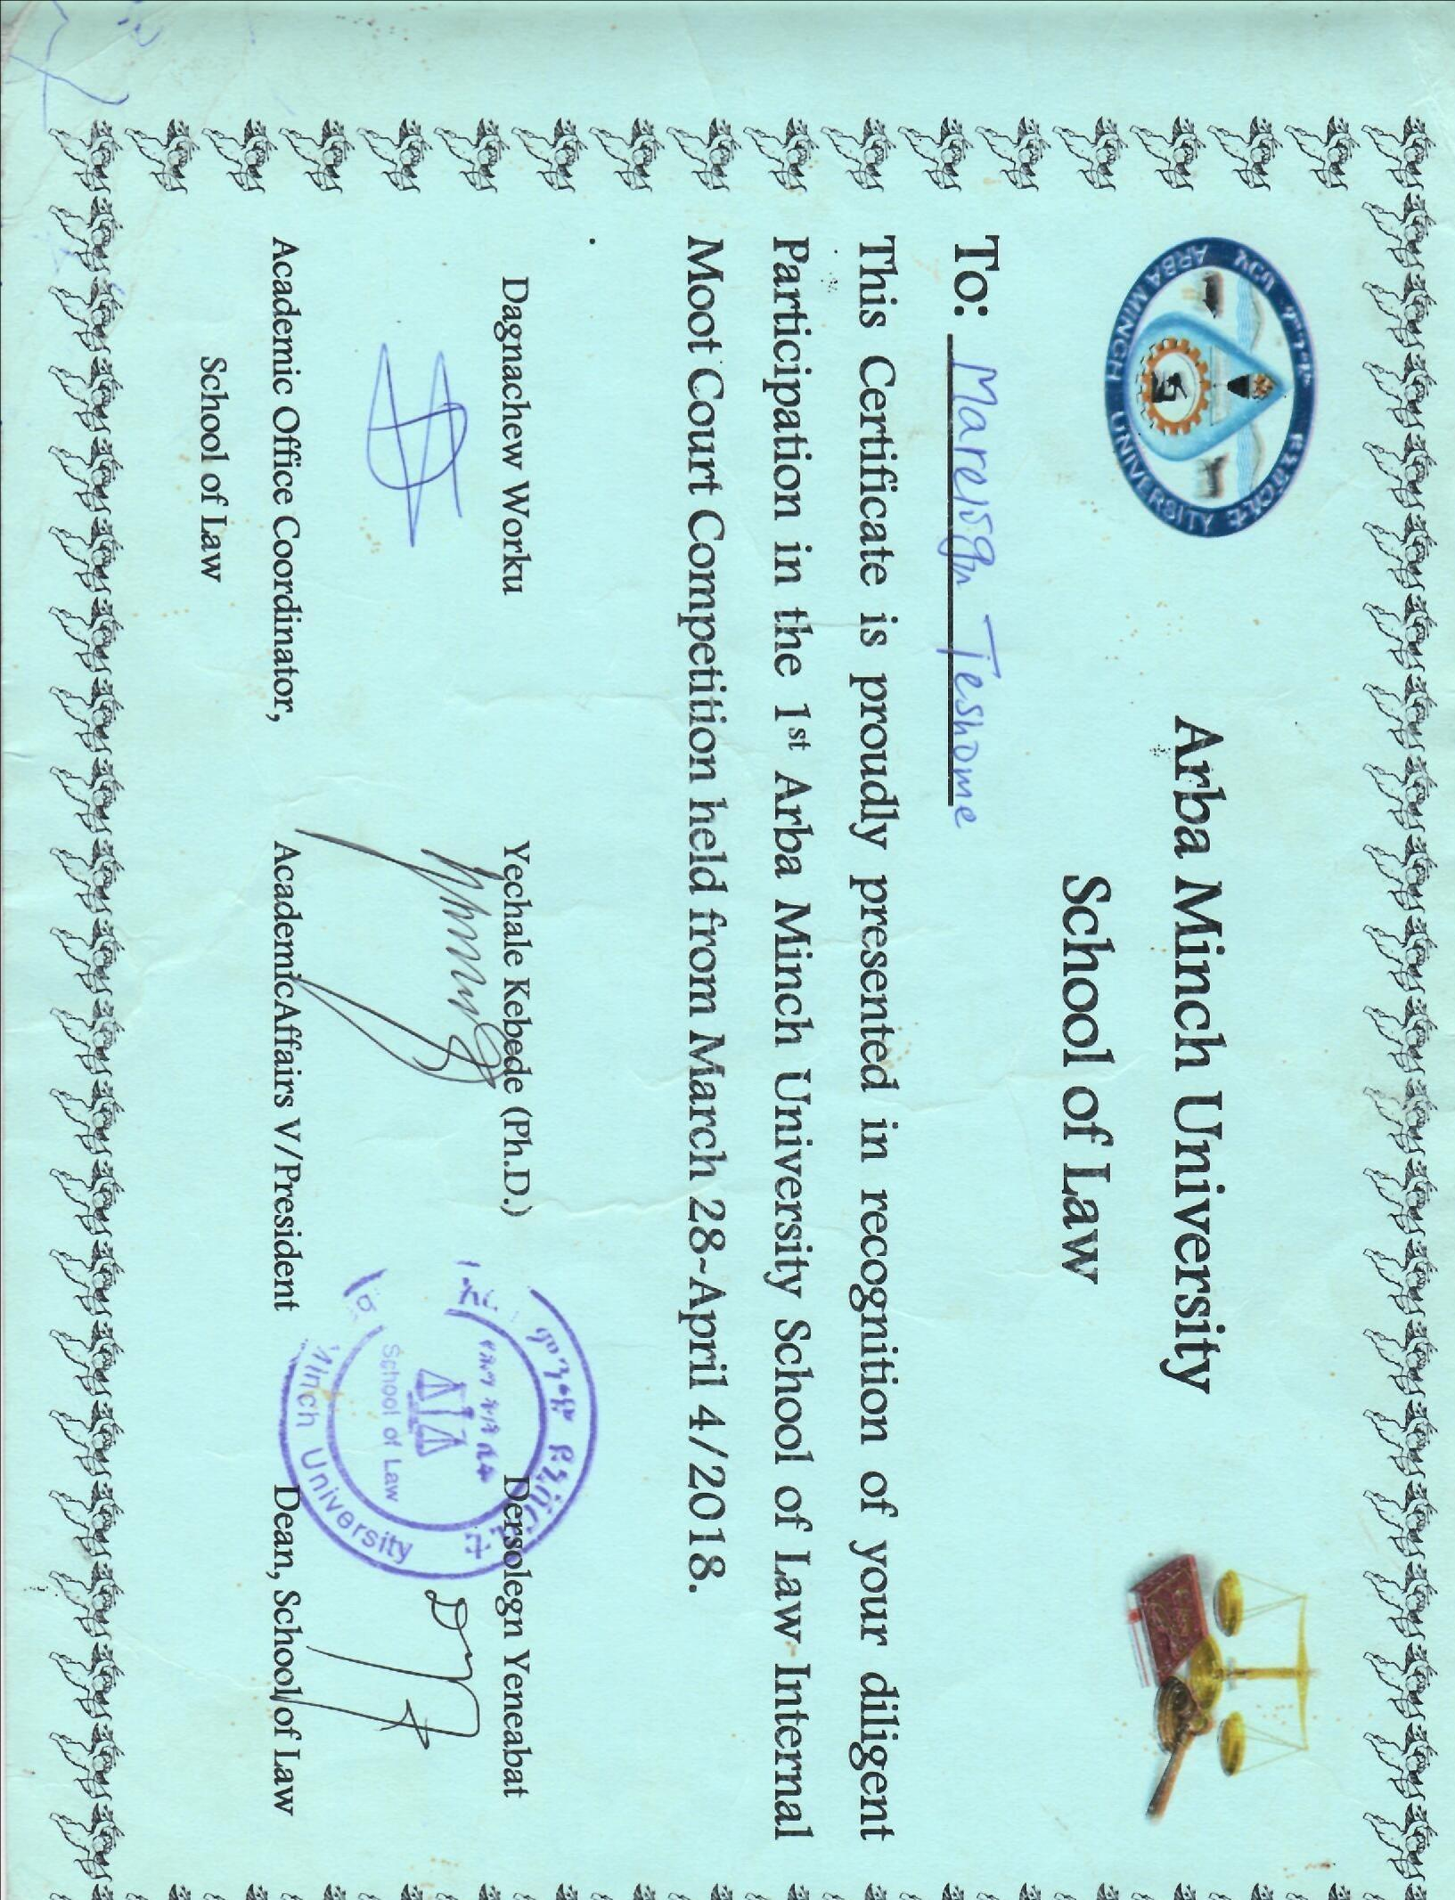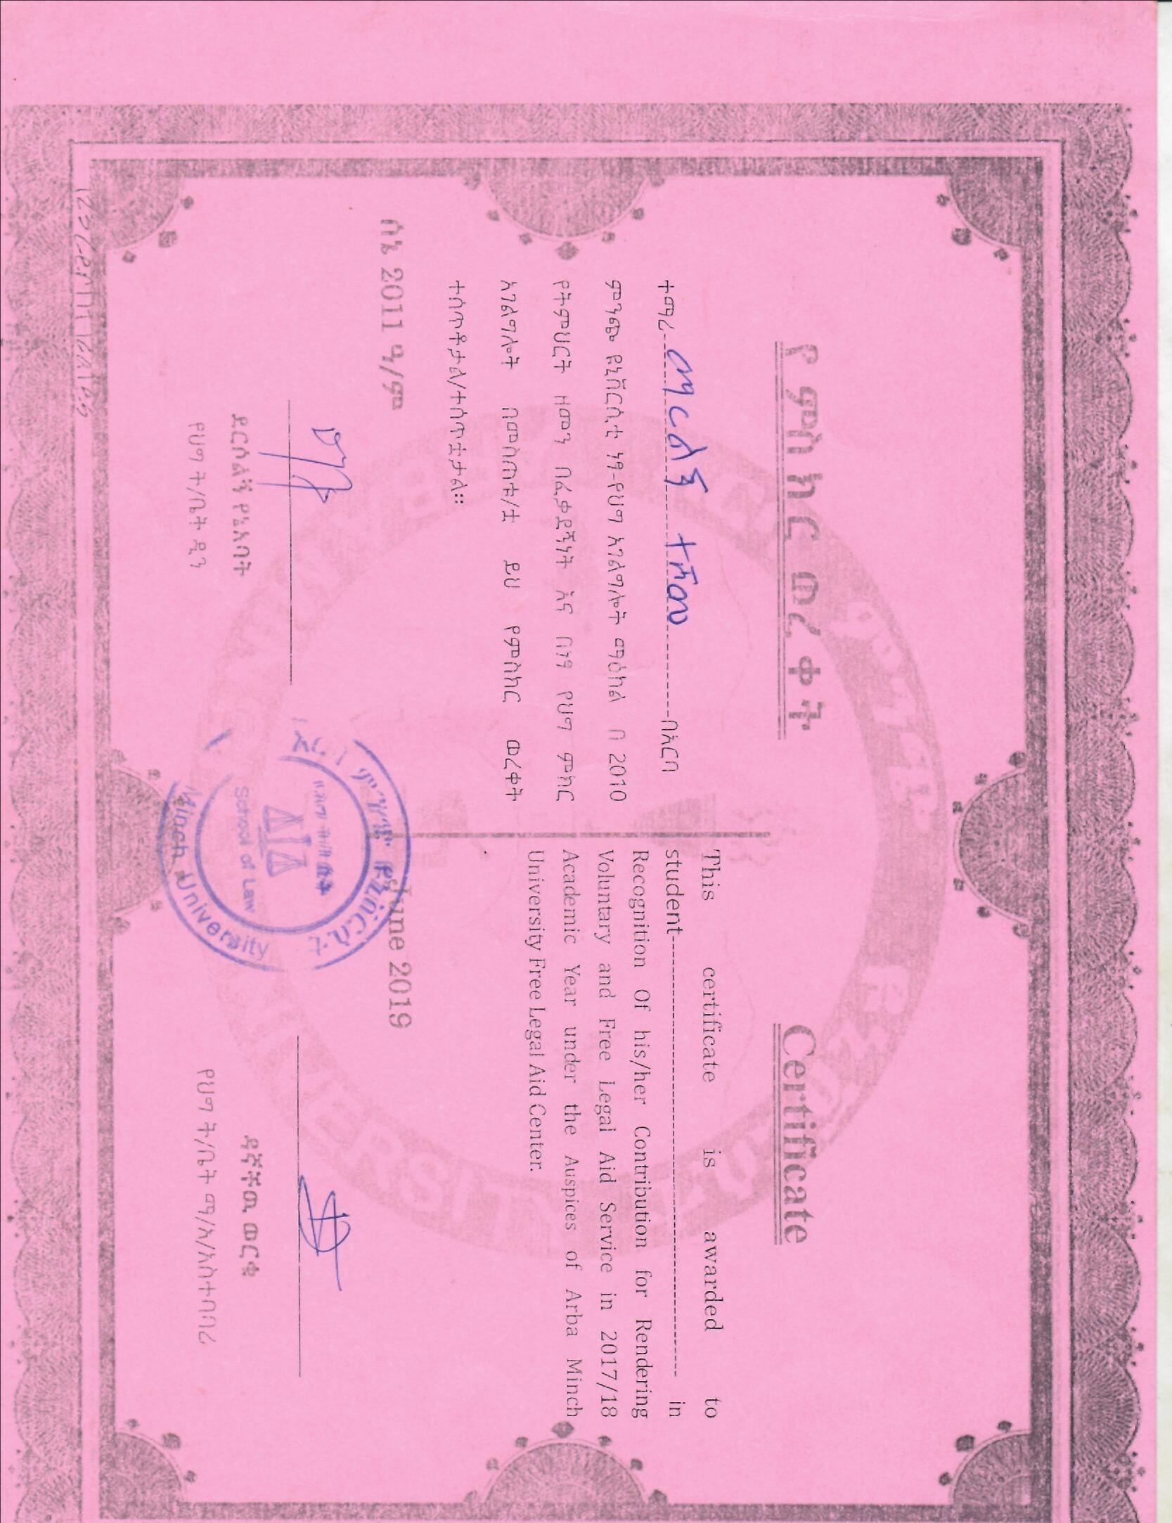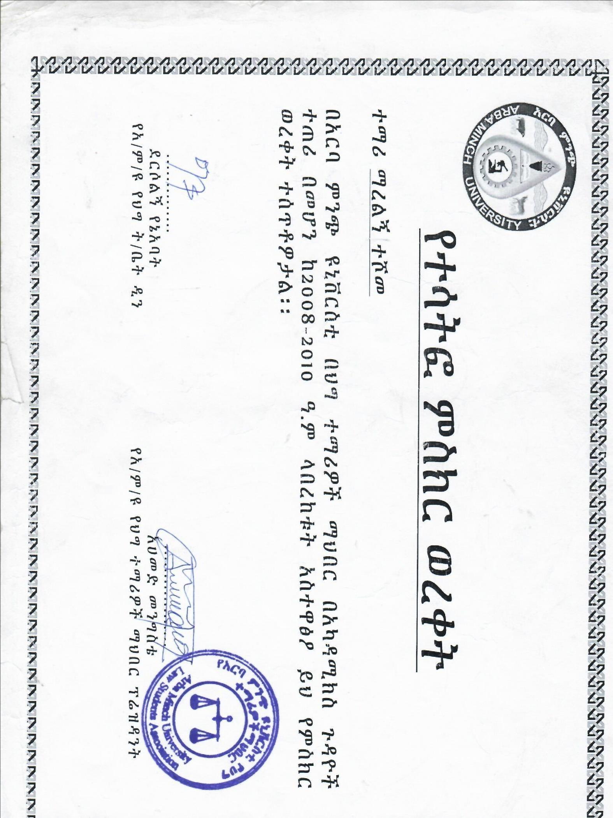
  3. 